**Idea Proposal Annexure**

**GearUP Season 3: Your Gateway to Smart india Hackathon**

**Team Name:** Bug Slayers

**Team Leader Name:** Anjali S Sinha

**Team Mentor (if any) NA**

**PSID:** SIH1592

(The document must not exceed more than 500 words)

**Title of the Proposed Idea:** Real -Time Food Waste Tracking and Penalty System

**Team Details**

|  |  |  |  |  |  |
| --- | --- | --- | --- | --- | --- |
|  | Name | Registration No | Email id | Gender | Contact(Whatsapp preferably) |
| Team Leader | Anjali S Sinha | 12206285 | anjalisinha0404@gmail.com | Female | 7709898342 |
| Team Member 1 | Kumari Khushi | 12215887 | ojhakhushi003@gmail.com | Female | 7061190897 |
| Team Member 2 | Gaurav Kumar | 12211179 | gauravatwork17@gmail.com | Male | 9007979492 |
| Team Member 3 | Priyanshu  Aswal | 12205812 | priyanshuaswal69@gmail.com | Male | 9084240563 |
| Team Member 4 | Swity yadav | 12212762 | swity6360@gmail.com | Female | 90641 88247 |
| Team Member 5 | Khusi Yadav | 12210769 | khusiyadav075@gmail.com | Female | 9877765994 |

1. **Problem Statement**:(State the Problem for which your idea is a justification)

In communal dining facilities such as hostels, substantial amounts of food are often wasted daily. This waste not only incurs unnecessary financial costs but also has a detrimental impact on the environment. Existing methods for managing food waste are generally ineffective, relying on indirect measurements or self-reporting, which often leads to inaccurate data and limited behavioral change. Furthermore, current systems for penalizing wasteful behavior lack real-time monitoring and immediate feedback, making it challenging to enforce effective waste reduction strategies. Additionally, tracking individual waste levels while ensuring privacy and accuracy poses a significant challenge.

1. **Solution of the Problem:**

To tackle these issues, we propose a software-based food waste management system featuring both an app and a website. The app will allow users to report and monitor food waste in real-time, while the website will provide administrators with tools to track and analyze waste data. By integrating real-time monitoring and automated penalties through the software, the system aims to deliver immediate feedback to users, promote responsible eating habits, and reduce food waste in hostel environments.

**3. Brief Description of the Working of the Idea** (The working must include any two of the following options : Block Diagram/Circuitdiagram/3D Model Design/Flow Chart).

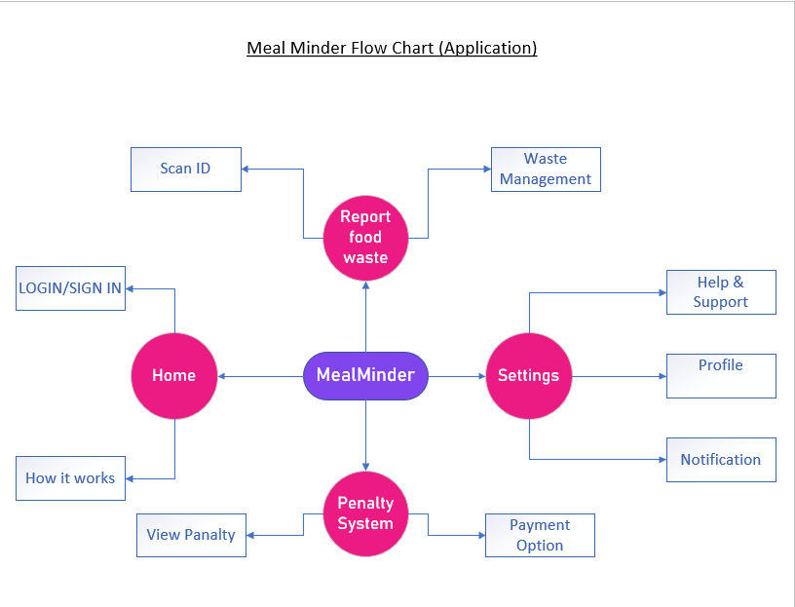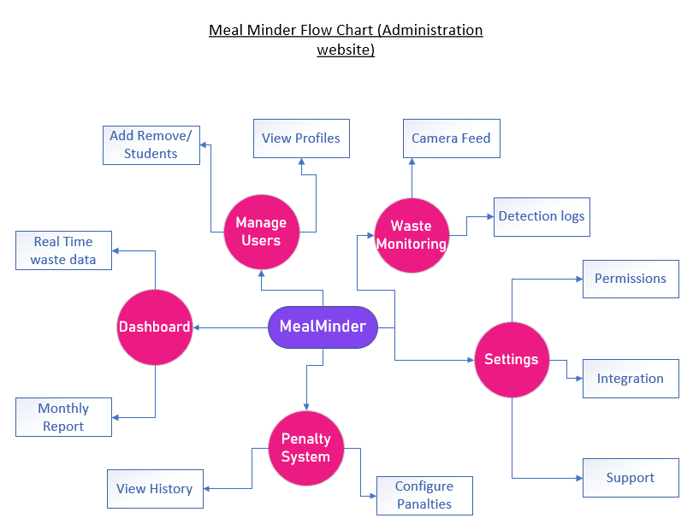

1. **Outcome of the Idea:**

**The software will:**

1. **Improve Waste Tracking**: Real-time data on food waste.
2. **Encourage Responsible Eating**: Automated feedback and penalties.
3. **Enhance Management**: Admin tools for waste analysis.
4. **Save Costs and Environment**: Reduce financial and environmental impacts.
5. **Increase Accountability**: Track individual waste and enforce penalties.

***Note:*** *It is mandatory for each team to have 6 members and must have 1 female member in the team*